|  |  |
| --- | --- |
| *Transdisciplinary Case Study of Health and Physical Activity in Old Age*  **SENIORS IN MOTION –**  **Transdisciplinary Approaches to Physical Activity Promotion for Older People**  **Case Description**  This Case Study draws on an existing transdisciplinary research project and refers to a real city in Germany to make regional context factors more tangible. Nevertheless, the case study contextualization is of a fictitious nature and includes certain elements merely to achieve the learning objectives. We encourage you to find out more about the specified region to make your project more concrete. However, we would like to ask you to not seek papers or information which relate to the actual implementation of the said transdisciplinary research project. This will allow you to unfold your full learning potential and creativity during the work on this case.  The structure of this Case Study is an adaptation of the Harvard Business Case Study model.  Written by F. Böttner, F. Tolksdorf, and D. Lam |  |

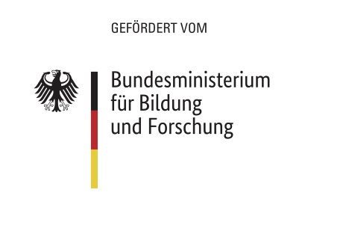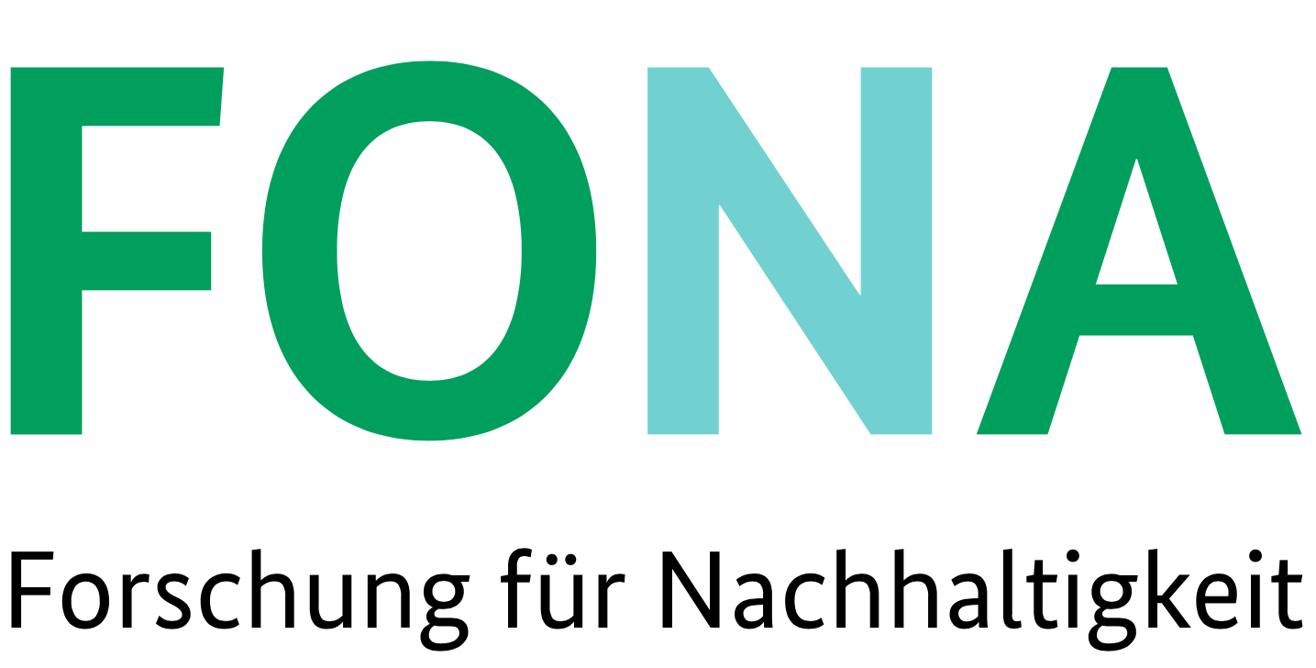

***It is early in the morning…***

...Your workday has just started as you open your e-mail inbox and discover a message from your friend Layla who works in the field of health research:

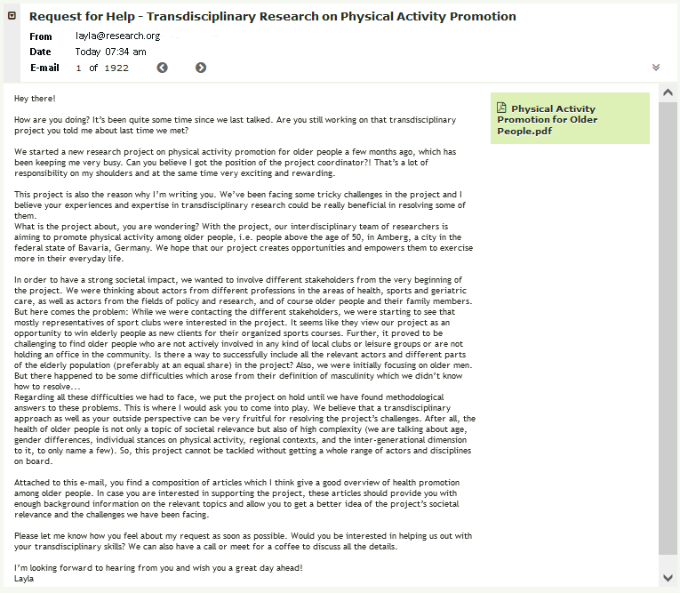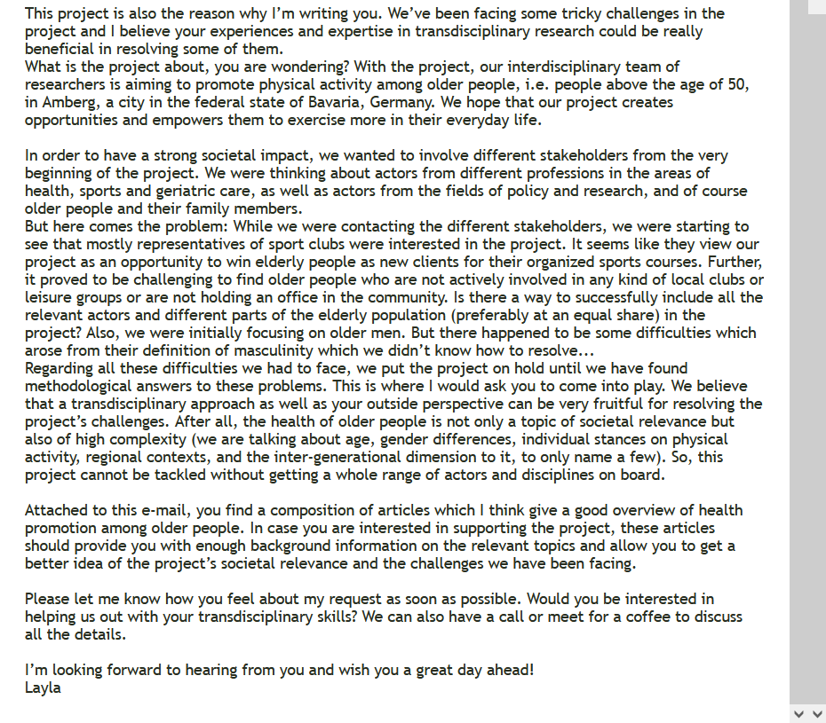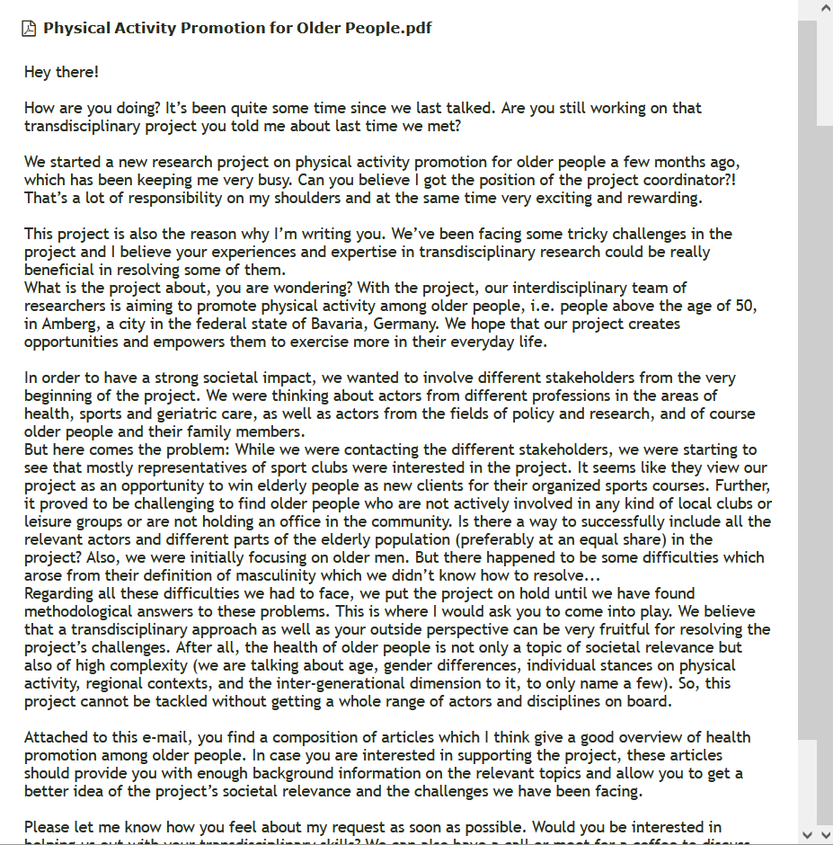

After reading Layla’s e-mail, you start thinking about your own grandparents’ health situation. Your grandpa is constantly complaining about his health and his decreasing ability to walk, but at the same time refuses to accept any physical activity program he gets offered to improve his physical mobility. “I’d rather turn into a snail than joining an aerobics group!”, he always says. Your grandma, in turn, has been a member of the local square dance group for a few years now – “to stay young and agile”, as she would add – but somehow still seems incredibly insecure about her personal health condition.

Your thoughts wander. From discussions with your friends, you know that problems of older people are not really something younger people are particularly interested in. And that’s understandable; in the end, younger people are in the prime of their lives and feel rather distant from physical impairments the proportion of older people in the society is confronted with. Nevertheless, you do find that younger people should recognize the importance of the current challenges society is facing due to older people’s health issues. Isn’t this a topic everyone should get involved in?

Either way, you yourself consider this topic important and are curious and excited about this new research opportunity. By lunch time you have made up your mind and agree on helping Layla with her project. You arrange a meeting to talk about the project details the next day. Before, you take a closer look at the material she attached to the e-mail (see pp. 3-4).

|  |  |  |  |  |
| --- | --- | --- | --- | --- |
| Greyler Publishing presents | | | | |
|  | **JOURNAL FOR HEALTH**  *Nr. 4 pp. 3-4* | | |  |
| *Source:* [*"Runkeeper and health on iPhone"*](https://www.flickr.com/photos/40493340@N00/8585047526)*by*[*Jason A. Howie*](https://www.flickr.com/photos/40493340@N00)*, licensed under*[*CC BY 2.0*](https://creativecommons.org/licenses/by/2.0/?ref=ccsearch&atype=rich) | | | Ensuring healthy lives and promoting well-being for all at all ages is the third out of 17 Sustainable Development Goals (SDGs). How can this be achieved in view of an aging society?  **Health in Old(er) Age** | |
| The older people get, the higher their likelihood of experiencing health impairments (see Fig. 1) (Federal Statistical Office, 2016). In Germany, more than half of the people who are 65 years of age and older endure one or more chronic diseases (OECD & WHO, 2019).  Chart, line chart  Description automatically generated  *Fig. 1. Health issues increase with age.*  *Source: Federal Statistical Office (2016), p. 19.*  As the proportion of older people in the world population as well as in Germany is growing (see Fig. 2), adapting the health and social systems to the changing demography has become a major challenge for countries worldwide (WHO, 2018). In Germany, life expectancy has steadily risen over the past decades (Federal Statistical Office, 2016) resulting into almost 50 percent of hospital patients exceeding the age of 65 (Federal Statistical Office, 2016)  *Fig. 2. Proportion of older people is growing. Source: Federal Statistical Office (2016), p. 48.*  **Reasons for poor health among older people are manifold.**    Overweight is a very prominent cause of health issues and affects more than half of the | | people over the age of 65 in Germany (Federal Statistical Office, 2016). Other risk factors among the German population include an unhealthy diet, smoking, excessive consumption of alcohol as well as too little exercise (see Fig. 3) (OECD & WHO, 2019). Even though adults in Germany engage in weekly physical activity more than adults in other EU countries do (OECD & WHO, 2019), the large majority (80 percent) of them still does not meet the recommendation of the World Health Organization to exercise at least 2.5 hours per week at a moderate intensity (Loss et al., 2020). Furthermore, people tend to exercise less the older they get (Loss et al., 2020).  A person swimming with a dolphin  Description automatically generated with medium confidenceChart, sunburst chart  Description automatically generated  *Fig. 3. Causes of public health problems.*  *Source: OECD & WHO (2019), p. 8.*  **For more information watch:**  **The elderly proportion of society is growing:** Aging Germany - an overview| People & Politics (Deutsche Welle, 2011); Relevant until 1:27 minutes.  **The importance and positive impacts of physical activity for older people.** Physical activity for older people (RACV, 2014). | **The Benefits of Physical Activity**    Regular physical activity immensely contributes to good health – no matter to which age group one belongs (Loss et al., 2020; Strobl, Brew-Sam et al., 2020). Thereby, the physical activity can comprise a low intensity exercise, like walking, just as a high intensity workout, as stated by Loss et al. (2020). For elderly people, regular exercise means a reduced risk of suffering from cardiovascular and metabolic diseases, osteoporosis, falls, and cognitive impairments, the authors clarify. Besides the overall health, mental health similarly profits from physical activity, as people are more likely to live longer and less likely to suffer from chronic diseases such as diabetes, hypertension, and different types of cancer (Loss et al., 2020; Strobl, 2020; Strobl, Brew-Sam et al., 2020). Additionally, regular exercising reduces the progression of already existing illnesses (Loss et al., 2020). In order to promote physical activity and self-health practices within the population, inter-ventions, i.e. measures which empower people to do sports on their own, are considered to be effective means (Strobl, 2020; Strobl, Brew-Sam et al., 2020 ).  Source: Federal Statistical Office (2016), p. 51. | |

|  |  |  |  |  |  |  |
| --- | --- | --- | --- | --- | --- | --- |
|  | | | | | **Personal health and well-being – a matter of Gender?**  Women’s and men’s life expectancy and health biographies heavily depend on their gender and more specifically on the sociocultural understanding of roles and values associated with gender that they were socialized with, according to Perrig-Chiello & Hutchison (2010). How masculinity and femininity are defined in their worldview affects their lifestyle and how they manage their health, as Perrig-Chiello & Hutchison (2010) explain. In fact, someone’s well-being in old age is to a large extent the result of an accumulation of gender-based inequalities which have built up throughout their life, the authors state further. Loss et al. (2020) conclude that physical activity promotion needs to be, in consequence, gender-sensitive. | |
| **A harmful understanding of masculinity**    Men over 50 years of age represent an important target group for health promotion as the physical activity recom-mendations of the World Health Organi-zation (WHO) are not achieved by a high share of older men (Loss et al., 2020). Additionally, their life expectancy is on average shorter than the one of women and their mortality rate in connection with chronic diseases is higher (Strobl, 2020; Strobl, Brew-Sam et al., 2020).  However, older men have also proven to be hard to reach by programs aiming to promote their health through physical activity (Strobl, 2020; Strobl, Brew-Sam et al., 2020).  On the one hand, this can be explained by several barriers that men perceive to physical exercise, such as phy-sical limitations, being afraid of incurring in-juries, not finding the time, or not having interesting opportuni-ties to exercise or ade-quate facilities available close to home (Loss et al., 2020). | On the other hand, topics and programs related to health and physical activity in general seem to appeal little to men as they do not align with men’s defi-nitions and perceptions of masculinity (Strobl, 2020; Strobl, Brew-Sam et al., 2020).  A person sitting at a table  Description automatically generated with medium confidence  Source: Photo by [Pavel Danilyuk](https://www.pexels.com/@pavel-danilyuk?utm_content=attributionCopyText&utm_medium=referral&utm_source=pexels) from [Pexels](https://www.pexels.com/photo/man-in-black-long-sleeve-shirt-holding-clear-drinking-glass-8057065/?utm_content=attributionCopyText&utm_medium=referral&utm_source=pexels) | | may it be medical or psychological, according to Perrig-Chiello & Hutchison (2010).  Further, to make health promotion and physical activity programs more appealing to men, pro-motion strategies that are gender-specific and thus work *with* the prevalent stereotypical understand-ding of masculinity have shown to be successful when targeting older men (Loss et al., 2020; Strobl, 2020).  However, making existing gender norms a subject of discussion is equally | |
| *“they are more likely to show a behavior which is harmful to one’s health“*  *(Strobl, 2020, p. 162)* | | | |
| Masculinity is associated with characteristics such as dominance and physical strength in Western socie-ties and leads men who hold this mindset to a behavior which is detri-mental to their health, e.g. by disregarding health issues, resorting to addic-tions or pursuing hazar-dous activities, Strobl (2020) explains.  Measures to improve men’s health could focus on incentivizing and en-couraging healthy life-styles, being more aware of and open about health problems, and accepting professional help early on, | | important, says Strobl (2020).  Thus, a physical activity promoting program should not only focus on physical exercise as such, but also stimulate reflection on one’s under-standing of masculinity, Strobl (2020) points out. That way, the behavior and attitude change prove to be more substantial and the program to be more effective in the end, the author concludes. | |
| A picture containing outdoor, tree, person, curb  Description automatically generated  Source: Photo by [Marcus Aurelius](https://www.pexels.com/@marcus-aurelius?utm_content=attributionCopyText&utm_medium=referral&utm_source=pexels) from [Pexels](https://www.pexels.com/photo/healthy-woman-relaxation-garden-6787202/?utm_content=attributionCopyText&utm_medium=referral&utm_source=pexels)  “Women tend to have a more holistic understanding of health.”  *(Perrig-Chiello & Hutchison, 2010, p. 210)* | | **A higher impairment of everyday functioning**    On average, women have a higher life expectancy than men. This is caused by a multi-tude of factors of biological, social, and behavioral nature, say Perrig-Chiello & Hutchison (2010). While genetic factors such as positive health effects of estrogen and a stronger immune system account for an approximately one to two years longer life span, socio-cultural gender-typical factors seem to have an even higher impact on the health differences between women and men, the authors state further. More precisely, women are socialized in a way to avoid risks and illness e.g., by refraining from hard drugs, alcohol, cigarettes, and risky activities of any sort, while they commonly invest more time and money in their well-being, con-sume more vitamins, and com-ply more strictly to medical re-commendations of their doctor (Perrig-Chiello & Hutchison, 2010). | | Nevertheless, health data show that women experience mor-bidity at a higher intensity and an earlier age than men and that they report suffering under physical problems, anxiety, and depression more often (Perrig-Chiello & Hutchison, 2010). Even though health issues experienced by women are less often terminal than for their male counterparts, those health problems affect the women’s everyday functioning more frequently, as Perrig-Chiello & Hutchison (2010) explain. This means that with age, they are more prone to falling, having other accidents and to being less independent due to decreased physical functioning and they depend more often on psycho-tropic drugs, Perrig-Chiello & Hutchison (2010) specify.  There are two explanations for why women are facing diseases more often throughout their lifetime than men, according to Perrig-Chiello & Hutchison (2010). On the one hand, their longer life expectancy leads to higher health risks in old age and furthermore increases the likelihood of negative events like the loss of family members | | and friends. On the other hand, women generally look at their health in a more holistic way than men – they do not only take performance and efficiency into account and are more aware and open about negative feelings they experience. This behavior, which Perrig-Chiello & Hutchison (2010) consider clearly related to socially constructed gender roles, leads to women reporting problems with their health and well-being more often than men, according to the authors.  Measures to support women in their health could thus not only focus on preventing loneliness, dementia, falls and fractures, but also increase their awareness of how their socialization and society’s definition of femininity is determining their own management of health, Perrig-Chiello & Hutchison (2010) emphasize. A stronger focus on self-confidence and agency can help women to feel more secure and confident regarding their health and well-being, the authors conclude. |

***The region of Amberg***

Next, you inform yourself about the region in which the project is being conducted to get to know the regional context the project is embedded in. According to your friend Layla, the project is implemented in the city of Amberg, the biggest community in the county of Amberg, in the federal state of Bavaria in Germany.

The city of Amberg has around 43.000 inhabitants and is located right between the Franconian Alb and the Upper Palatinate Forest (Amt für Tourismusförderung Amberg, 2015). A third of the city area is covered with forest which is a way higher percentage than in any other Bavarian city (Stadt Amberg, undated-b). Thus, Amberg offers its citizens a number of local recreation areas, not only outside the city but also close to its old town, which provide the Amberg population with opportunities for physical activity and active living in nature (Stadt Amberg, undated-b).

Amberg presents itself as a modern city while placing a high value on preserving local traditions at the same time (Amt für Tourismusförderung Amberg, 2015; Stadt Amberg, undated-a, undated-e). Several clubs and associations exist where the old and the young get involved in cultural activities, historical topics, folklore dancing, collective singing, and much more (Stadt Amberg, undated-f). Further, a wide range of political organizations exist (Stadt Amberg, undated-c).

5

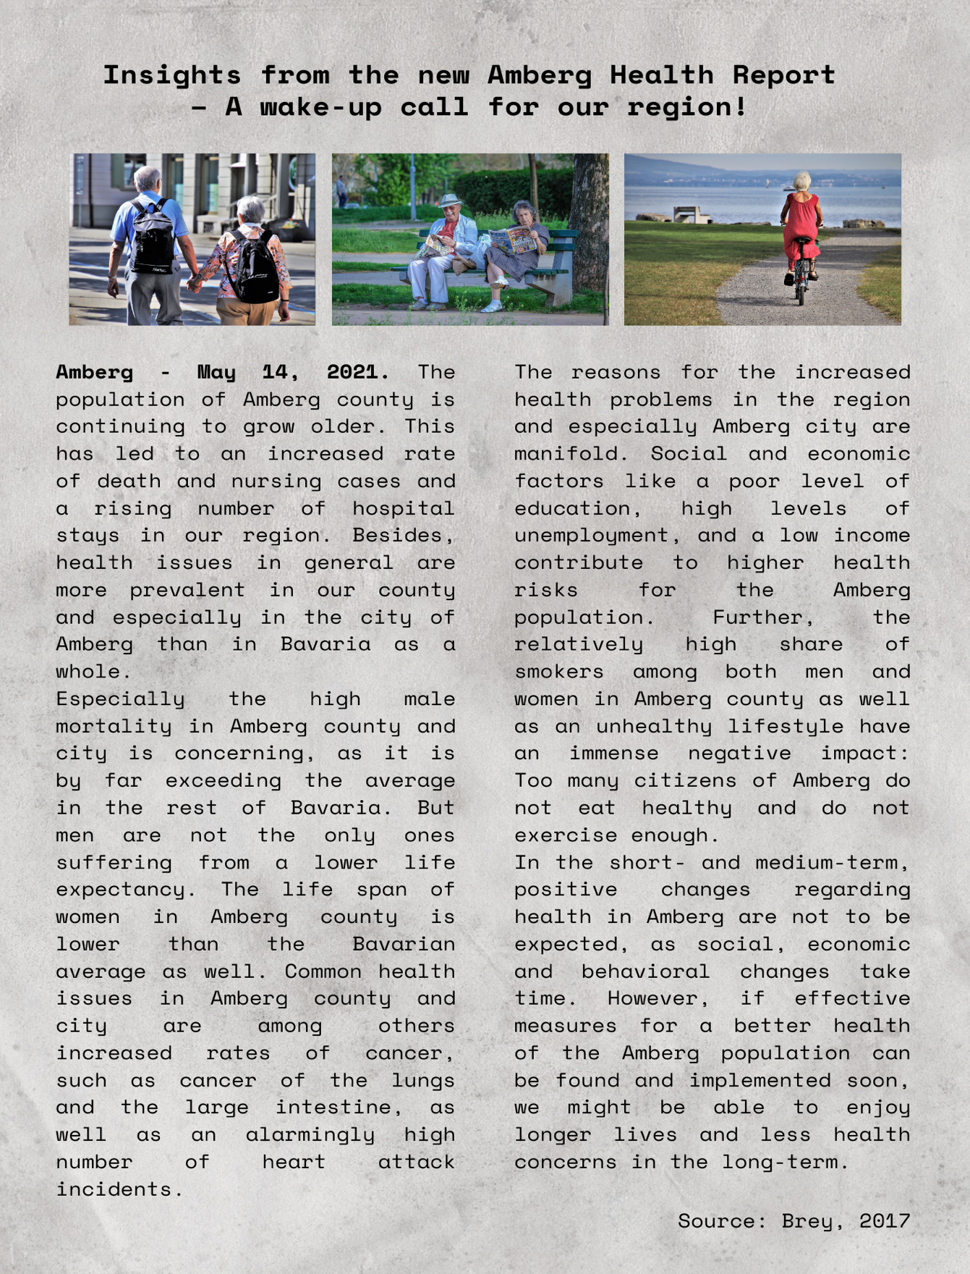As you are particularly interested in the health situation of older people in the region of Amberg, you are conducting a brief online research and come across a pertinent article (see Article 1 below) in the local newspaper (Brey, 2017). To your surprise, the health data does not seem to reflect the potential which lies in Amberg’s promising location given its proximity to nature and to recreational areas. During your online research you further discover several contact points, networking opportunities, physical activity offers, and health advice services which already exist for older people in the region. In addition, you get to know about stakeholder groups that likewise have an interest in the promotion of physical activity among Amberg’s seniors. You note them down in a table (see appendix A, pp. 13-14).

Article 1: Health Situation in Amberg.

Having found a first list of actors you could potentially cooperate with you start wondering how you could involve a diversity of stakeholders in the project; preferably a group of actors which represents the social significance of this topic. You feel like, your stakeholder group should also include those actors who are neither employed in health and geriatric care nor occupied with physical activity promotion in one way or another. Maybe community groups and local clubs could get involved – after all, they do seem to play an important role in the area. Which further actors could there be? You decide to keep this thought in mind for when it’s time to concern yourself more intensely with the stakeholder selection and recruitment.

***Preparing the Project – Potential Approaches and Methods***

The collection of articles on physical activity promotion among older people as well as the project details again convinced you of the immense relevance of this research project. You feel an inner dedication to bring the research in this field forward and to find a way to encourage older people in being physically active at the same time.

You know that you need to find concrete methods, theoretical concepts, and tools to effectively address the target group and include all the stakeholders relevant to the transdisciplinary project. In no time, you start gathering concepts from the literature as well as from projects you have previously worked on.

After an hour of intense work, your preliminary findings comprise of a few approaches for physical activity promotion (see Box 1 + 2, p. 8) and methods for transdisciplinary projects (see Box 3 + 4, appendix C, pp. 15-16) You decide to continue your search for further potential methods and approaches at a later time, once you have discussed the project details with the rest of the team.

***Potential Approaches for Physical Activity Promotion***

Preventive measures carry a high importance for improving a society’s health situation as chronic diseases in old age can be avoided by following a healthier lifestyle and addressing the social factors behind such lifestyles and health behaviors (Perrig-Chiello & Hutchison, 2010).

Approaches to plan and implement physical activity programs can be of a diverse nature. Those approaches can involve a set group of stakeholders, the cooperation with voluntary or non-governmental organizations, quality circles with employees of the healthcare sector, or empowerment workshops for (inactive) community members (Loss et al., 2020). A mix of different participatory approaches can facilitate the involvement of actors with different preferences regarding their participation in such exchanges and might allow for a larger variety of represented mindsets and ideas (Loss et al., 2020). Giving different stakeholders the opportunity to express their personal experience with health promotion activities in their community as well as to contribute with their professional knowledge in this field is considered crucial (Strobl, Brew-Sam et al., 2020).

***Box 2: Capacity Building***

*In the field of health promotion, capacity building has been found to be an effective and relevant approach to establish programs for health promotion within a community in the long-term (Loss et al., 2020).* ***Older people*** *seem to be reached particularly well through such local capacity building interventions which holds a high potential for the promotion of their physical exercise (Loss et al., 2020).*

*Capacity Building can be used* ***to encourage and strengthen communities and their representatives*** *to tackle their concerns effectively (Loss et al., 2020). This is done by drawing on existing resources and by developing the required skills and structures among the community members (Strobl, Brew-Sam et al., 2020). As a result, individuals as well as organizations within the community are mobilized, increasingly able to organize themselves and take on responsibility and active ownership over the given issues and processes (Strobl, Brew-Sam et al., 2020).*

*The* ***involvement of diverse stakeholders*** *and their interaction among one another is crucial for the capacity building process as well as the resulting capacity (Strobl, Brew-Sam et al., 2020). The stakeholders can be scientific experts, citizens, administrative representatives of the municipality, organizations, or professionals of health promotion (Strobl, Brew-Sam et al., 2020).*

***Box 1: Participatory Interventions in a Community Setting***

To **attain difficult-to-reach target groups** with health promotion programs, the municipal setting such as a city or community has proven to be suitable for several reasons (Strobl, Brew-Sam et al., 2020). Firstly, it unites diverse groups of actors who offer physical activity programs and can profit from additional support and coordination (Strobl, Brew-Sam et al., 2020). Secondly, the community setting allows health promotion to be adapted to the regional context, such as demands, available resources, and local possibilities (Loss et al., 2020). Thirdly, conducting health promotion programs in a community setting allows for interaction with people in their familiar surroundings (Loss et al., 2020).

**Participatory interventions** have been successfully used to realize health promotion activities in different settings such as communities (Strobl, Brew-Sam et al., 2020). For participatory interventions, a variety of community members gets involved into the collaborative planning, implementation and evaluation process of the health-promoting activities (Strobl, Brew-Sam et al., 2020). Community members such as stakeholders, employees, or spokespersons of different population groups can come together through participatory programs such as stakeholder groups or community health committees (Loss et al., 2020). The inclusion of different actors is crucial in order that needs-based and effective interventions can be designed and implemented and thus lead to long-lasting structural changes in the community (Loss et al., 2020).

***Building up a transdisciplinary research project***

After looking into the different concepts (Box 1 – 4), you meet up with your friend and the rest of the research team to decide on the further proceedings.

***Main Task of the Case Study***

With your research team, develop a transdisciplinary research project spanning 3 years. Your goal is to research as well as promote physical activity of men and women 50+ in the city of Amberg, Bavaria.

Orientate your project setup on the three phases of the transdisciplinary research process outlined by Lang et al. (2012) and set out concrete steps and methods for each phase as well as a time schedule for the entire project duration.

Make sure to adapt your project design to the **regional context of Amberg city**. To this end, you can make use of the information about Amberg provided in this case study contextualization. Feel free to expand your knowledge on the regional context by conducting additional research.

Additionally, the **stakeholders** you choose to collaborate with will influence your project design. An incomplete list of potential stakeholders of the region (see appendix A, pp. 13-14) can help you with the selection. However, don’t hesitate to look up further relevant stakeholders on your own. When working with (a diverse group of) stakeholders, several challenges can arise. In appendix B (p. 15), a few questions for reflection can help you in planning the stakeholder engagement.

Moreover, your group can choose from different **thematic foci**, or challenges respectively, which you will address in particular throughout your project. The thematic foci are explained in more detail below.

Finally, you are free to decide whether you adopt the **potential approaches and methods** which are briefly introduced in appendix C (pp. 15-16) for your transdisciplinary approach. Here again, we encourage you to conduct your own search for appropriate research methods and elements for this transdisciplinary context.

You will have unlimited personal and financial resources. If necessary, you can make assumptions on what is happening and how these developments impact your project process.

***Choosing a thematic focus***

Your friend Layla and the literature have pointed you towards further context-related aspects which are of relevance when setting up a transdisciplinary project in the field of physical activity promotion of older people in Amberg. Thus, your group can choose between different thematic foci and challenges you want to address within the project (see next page).

***Focus 1: Reaching the target group of older people***

Physical activity promotion for older people comes with its own set of challenges. In the past, some members of this age group could not be reached (Stadt Amberg, undated-d; Strobl, 2020; Strobl, Brew-Sam et al., 2020) e.g., because the offers were considered unappealing, the older people lacked contacts to other seniors and were not socially engaged, or because they suffered from old-age poverty and could not afford to participate in certain offers. In other cases, a limited mobility or movement difficulties of the seniors addressed prevented them from making their way to the venue. Moreover, the reasons for why different seniors suffer from poor health are manifold and need to be considered carefully (see composition of articles, pp. 3-4). *When designing and implementing your project, make sure to take into account these target group specific challenges and particularly reflect on how far the interests of the stakeholders you collaborate with align with the older people’s needs.*

***Focus 2: Physical activity promotion as a matter of gender***

The way people deal with personal well-being and health issues is largely dependent on their gender. So is their perception of offers for physical activity promotion. In fact, many physical activity offers are unsuccessful in addressing men and hence are predominantly frequented by women. However, older women are anything but free from health impairment and further often hold a lower confidence in their health than men (see composition of articles, pp. 3-4). *During your project, put particular emphasis on gender (stereotypes) and gender-sensitive approaches – not only when devising solutions for physical activity promotion for older people, but also during the entire research process, including the collaboration with stakeholders and the implementation of transdisciplinary methods. How can your project appeal to citizens of all gender and contribute to breaking down gender stereotypes and making this a subject of discussion at the same time?*

***Focus 3: Physical activity promotion as an inter-generational endeavor***

Which key experiences, influential factors, and turning points are there in life that affect how we value sports at a given point and to what extent we include physical exercise in our everyday life? One’s sports biography doesn’t start in old age. In fact, exercise habits in older age also depend on which role sports played during one’s childhood and youth (Hirvensalo & Lintunen, 2011). Young people hence represent an important target group when aiming to promote physical activity among older people in the long-term (Hirvensalo & Lintunen, 2011). At the same time, young people often find it difficult to relate to and empathize with older people’s needs and difficulties. *During your project, focus on actively addressing and involving younger people and making this a true inter-generational undertaking.*

***Focus 4: Tracking down the value of sports to Amberg citizens***

People do not value sports and the different aspects there are to it in an equal manner (Jetzke & Mutz, 2020). To some, doing sports might imply being outdoors or spending time with friends, while others particularly appreciate the health benefits they derive from physical activity. To others, in turn, exercise is no more than free time and fun. Which value does the Amberg population see in physical activity? *Consider the differences in how people relate to sports in your project design to reach the members of the different target groups effectively and to come up with viable solutions.*

***Focus 5: Your Personal Topic of Interest***

Which challenges do you see regarding the promotion of physical activity among older people in Amberg? *Feel free to focus your project on an even different topic (beyond Focus 1-4) and elaborate on your own ideas and interests.*

***Image content***

**Picture 1, p. 2:** Yan Krukov (2021). An Elderly Woman Using a Hula Hoop [Photograph]. Available at https://www.pexels.com/photo/an-elderly-woman-using-a-hula-hoop-6815661/, last accessed on 11.10.2021.

**Picture 2, p. 2:** MART PRODUCTION (2021). Man in Brown Sweater Using a Laptop [Photograph]. Available at https://www.pexels.com/photo/man-in-brown-sweater-using-a-laptop-7330163/, last accessed on 11.10.2021.

**Picture 3, p. 2:** RUN 4 FFWUP (2019). Female and Male Runners on a Marathon [Photograph].Available at https://www.pexels.com/photo/female-and-male-runners-on-a-marathon-2402777/, last accessed on 11.10.2021.

**Picture 4, p. 2:** Kampus Production (2021). Man in Yellow Sweater Holding Man in Black Shirt [Photograph]. Available at https://www.pexels.com/photo/man-in-yellow-sweater-holding-man-in-black-shirt-7551611/, last accessed on 11.10.2021.

**Picture 5, p. 2:** Anna Shvets (2020). Woman in Black Tank Top and White Knee High Socks Sitting on Black Seat [Photograph]. Available at https://www.pexels.com/photo/fashion-man-love-people-4587382/, last accessed on 11.10.2021.

**Picture 6, p. 5:** MdE (2005). View over Auerbach in Bavaria, Germany. [Photograph]. Available at https://commons.wikimedia.org/w/index.php?curid=1023044, last accessed on 29.09.2021.

**Picture 7, p. 6:** pasja1000 (2018). Old man and woman holding hands [Photograph]. Available at https://pixabay.com/de/photos/senior-alten-menschen-paar-3336451/, last accessed on 11.10.2021.

**Picture 8, p. 6:** besnopile (2017). Old man and woman on bench [Photograph]. Available at https://pixabay.com/de/photos/gro%c3%9feltern-alt-senior-oma-2807673/, last accessed on 11.10.2021.

**Picture 9 p. 6:** pasja1000 (2020). Old woman riding the bike [Photograph]. Available at https://pixabay.com/de/photos/park-fahrrad-senior-einsam-5528190/, last accessed on 11.10.2021.

**Picture 10, p. 7:** Pixabay (2016). Close Up Photography of Yellow Green Red and Brown Plastic Cones on White Lined Surface [Photograph]. Available at https://www.pexels.com/photo/close-up-photography-of-yellow-green-red-and-brown-plastic-cones-on-white-lined-surface-163064/, last accessed on 11.10.2021.

**Picture 11, p. 8:** Noelle Otto (2017). Old Couple Walking While Holding Hands [Photograph]. Available at https://www.pexels.com/photo/old-couple-walking-while-holding-hands-906111/, last accessed on 11.10.2021.

***References***

Amt für Tourismusförderung Amberg. (2015). Fakten zur stadt amberg: modernes zentrum mit tradition. https://tourismus.amberg.de/index.php/die-fakten-der-stadt.html

Brey, R. (2017). Gesundheit in der Region – auf einen Blick: Zusammenfassung. Amberg. Gesundheitsamt Amberg. https://www.kreis-as.de/Gesundheit-Verbraucherschutz/Gesundheit/Gesundheitsamt/weitere-Infos-von-A-Z/

Federal Statistical Office. (2016). Older people in Germany and the eu. https://www.destatis.de/EN/Themes/Society-Environment/Population/Current-Population/Publications/Downloads-Current-Population/brochure-older-people-eu-0010021169004.pdf?__blob=publicationFile

Gelius, P., Brandl-Bredenbeck, H. P., Hassel, H., Loss, J., Sygusch, R., Tittlbach, S., Töpfer, C., Ungerer-Röhrich, U., & Pfeifer, K. (2021). Kooperative Planung von Maßnahmen zur Bewegungsförderung : Neue Wege zur Erweiterung von Handlungsmöglichkeiten – Ergebnisse aus dem Forschungsverbund Capital4Health [Cooperative planning of measures to promote physical activity : New paths for expanding capabilities-results from the Capital4Health research consortium]. Bundesgesundheitsblatt, Gesundheitsforschung, Gesundheitsschutz, 64(2), 187–198. https://doi.org/10.1007/s00103-020-03263-z

Hirvensalo, M., & Lintunen, T. (2011). Life-course perspective for physical activity and sports participation. European Review of Aging and Physical Activity, 8(1), 13–22. https://doi.org/10.1007/s11556-010-0076-3

Jetzke, M., & Mutz, M. (2020). Sport for pleasure, fitness, medals or slenderness? Differential effects of sports activities on well-being. Applied Research in Quality of Life, 15(5), 1519–1534. https://doi.org/10.1007/s11482-019-09753-w

Lang, D. J., Wiek, A., Bergmann, M., Stauffacher, M., Martens, P., Moll, P., Swilling, M., & Thomas, C. J. (2012). Transdisciplinary research in sustainability science: Practice, principles, and challenges. Sustainability Science, 7(S1), 25–43. https://doi.org/10.1007/s11625-011-0149-x

Loss, J., Brew-Sam, N., Metz, B., Strobl, H., Sauter, A., & Tittlbach, S. (2020). Capacity building in community stakeholder groups for increasing physical activity: Results of a qualitative study in two german communities. International Journal of Environmental Research and Public Health, 17(7). https://doi.org/10.3390/ijerph17072306

MdE. (2005). Blick über auerbach in niederbayern [CC BY-SA 3.0]. <https://de.wikipedia.org/wiki/Auerbach_(Landkreis_Deggendorf)#/media/Datei:Auerbach_Niederbayern.jpg>

OECD; WHO. (2019). Country Health Profile 2019: Germany. State of Health in the EU. OECD Publishing. https://www.euro.who.int/__data/assets/pdf_file/0005/419459/Country-Health-Profile-2019-Germany.pdf

Perrig-Chiello, P., & Hutchison, S. (2010). Health and well-being in old age: The pertinence of a gender mainstreaming approach in research. Gerontology, 56(2), 208–213. https://doi.org/10.1159/000235813

Popp, J., Carl, J., Grüne, E., Semrau, J., Gelius, P., & Pfeifer, K. (2020). Physical activity promotion in german vocational education: Does capacity building work? Health Promotion International, 35(6), 1577–1589. https://doi.org/10.1093/heapro/daaa014

Rütten, A., Dieck, M., Borgogni, A., Kalvenas, A., Kolb, M., Schouenborg, J., Suomi, K., & Pierik, F. on behalf of the IMPALA.net Project. (2017). IMPALA Toolkit: Steps for Implementing the European IMPALA Guidelines For Improvement of Infrastructures for LeisureTime Physical Activity in the Local Arena. Copenhagen. Institute of Sport Science and Sport (ISS) Friedrich-Alexander University Erlangen-Nuremberg (FAU).

Stadt Amberg. (undated-a). Heimat & geschichte. https://www.amberg.de/kultourismus/heimat-geschichte

Stadt Amberg. (undated-b). Naherholungsgebiete. https://www.amberg.de/leben-in-amberg/freizeit-und-sport/naherholungsgebiete

Stadt Amberg. (undated-c). Parteien & gruppen. https://www.amberg.de/rathaus/stadtrat-politik/parteien-und-gruppen

Stadt Amberg (Ed.). (undated-d). Seniorenpolitisches Gesamtkonzept. https://www.amberg.de/fileadmin/Soziales/Seniorenpolitisches_Gesamtkonzept.pdf

Stadt Amberg. (undated-e). Standortprofil. https://www.amberg.de/rathaus/standortprofil

Stadt Amberg. (undated-f). Vereine & verbände. https://www.amberg.de/leben-in-amberg/freizeit-und-sport/vereine-verbaende

Strobl, H. (2020). Theoretical underpinnings of interventions that effectively promote physical activity in adult men. German Journal of Exercise and Sport Research, 50(1), 162–178. https://doi.org/10.1007/s12662-019-00631-z

Strobl, H., Brew-Sam, N., Curbach, J., Metz, B., Tittlbach, S., & Loss, J. (2020). Action for men: Study protocol of a community capacity building intervention to develop and implement gender-sensitive physical activity programs for men 50 plus. Frontiers in Public Health, 8, 1–9. https://doi.org/10.3389/fpubh.2020.00004

United Nations. (undated). Goal 3: ensure healthy lives and promote well-being for all at all ages. https://sdgs.un.org/goals/goal3

WHO. (2018). Ageing and health. https://www.who.int/news-room/fact-sheets/detail/ageing-and-health

***Appendix A:***

***Potential Stakeholders***

*An incomplete list of potential stakeholders of the region of Amberg, including contact points, networking opportunities, physical activity offers, and health advice services for older people as well as stakeholder groups that have an interest in the promotion of physical activity among Amberg’s seniors.*

|  |  |  |
| --- | --- | --- |
| Name | Description | Link |
| Contact Points, Networking Opportunities and Activities for Older People in Amberg | | |
| Municipal Office for Seniors | information and help desk | <https://www.amberg.de/rathaus/aemter-referate/soziales/seniorenstelle> |
| Seniors Forum | advocates for old people’s interests to improve their quality of life | [https://www.amberg.de/leben-in-amberg/familie/50plus-senioren/ seniorenforum](https://www.amberg.de/leben-in-amberg/familie/50plus-senioren/seniorenforum) |
| Seniors Network | information platform for seniors and their relatives | <https://www.seniorennetz-amberg.de/> |
| Senior Citizens’ Clubs and Organizations | church groups, political parties, social organizations, labor unions, others | [https://www.amberg.de/leben-in-amberg/familie/50plus-senioren/ seniorenclubs](https://www.amberg.de/leben-in-amberg/familie/50plus-senioren/seniorenclubs) |
| Seniors Afternoons | semi-annual event for 2500 seniors of the city | <https://www.amberg.de/leben-in-amberg/familie/50plus-senioren> |
| Physical Activity Offers and Health Advice Services for Older People in Amberg | | |
| Database „Fit and Active in Old Age” | courses, consultation offers, chat circles, and services for seniors and their relatives | <https://seniorennetz-amberg.de/suche.php?angebot-kategorie=2> |
| Sports offers for seniors by various sports clubs | ./. | [https://www.amberg.de/leben-in-amberg/ freizeit-und-sport/vereine](https://www.amberg.de/leben-in-amberg/freizeit-und-sport/vereine) |
| 50plus Day of Healthy and Active Living | annual event for seniors and their relatives comprising workshops, expert presentations, information booths, and more | [https://www.amberg.de/leben-in-amberg/familie/50plus-senioren/ 50plus-fit-aktiv-tag](https://www.amberg.de/leben-in-amberg/familie/50plus-senioren/50plus-fit-aktiv-tag) |
| Seniors Sports and Exercise Park | age-appropriate training possibilities | [https://www.amberg.de/fileadmin/Soziales/ Seniorenpolitisches_Gesamtkonzept.pdf](https://www.amberg.de/fileadmin/Soziales/Seniorenpolitisches_Gesamtkonzept.pdf)  (page 74) |
| Research / Universities in the region | | |
| University of Regensburg | Professorship of Medical Sociology: Research on Prevention and Health Promotion | <https://www.uni-regensburg.de/medizin/epidemiologie-praeventivmedizin/institut/professur-fuer-medizinische-soziologie/praevention-und-gesundheitsfoerderung/index.html> |
| University of Bayreuth | Chair in Social and Health Sciences in Sport: Research on Physical Activity and Health | <https://www.spowi3.uni-bayreuth.de//en/research/index.html> |

|  |  |  |
| --- | --- | --- |
| Policy | | |
| State Office for Health and Food Safety, Bavaria | ./. | <https://www.lgl.bayern.de/> |
| Public Health Department, Amberg county | ./. | [https://www.kreis-as.de/Gesundheit-Verbraucherschutz/Gesundheit/ Gesundheitsamt](https://www.kreis-as.de/Gesundheit-Verbraucherschutz/Gesundheit/Gesundheitsamt) |
| District Administration, Amberg county | ./. | <https://landratsamt.amberg-sulzbach.de/landratsamt/sachgebiete.php> |
| Bavarian Working Group on Prevention (LAGeP) | Representatives of research, policy, and practice | [https://www.lgl.bayern.de/gesundheit/ praevention/lagep/index.htm](https://www.lgl.bayern.de/gesundheit/praevention/lagep/index.htm) |
| Netzwerk Gesundheitsregion plus | Network of actors from different fields working on measures for health promotion, healthcare, nursing care, and prevention | <https://www.amberg.de/leben-in-amberg/gesundheit/gesundheitsregion>  [https://www.kreis-as.de/Start/Gemeinsame-Gesundheitsoffensive-jetzt-auch-im-Namen-vermerkt.php?object=tx,3131.5&ModID=7& FID=3131.21402.1&NavID=2026.7](https://www.kreis-as.de/Start/Gemeinsame-Gesundheitsoffensive-jetzt-auch-im-Namen-vermerkt.php?object=tx,3131.5&ModID=7&FID=3131.21402.1&NavID=2026.7) |
| Professionals | | |
| physiotherapists | ./. | ./. |
| doctors and geriatric nurses | ./. | ./. |
| sports clubs and fitness centers | ./. | ./. |
| health insurance companies | ./. | ./. |
| Population Groups | | |
| Older people and their relatives | ./. | ./. |
| Adult Education Center | Volkshochschule Amberg-Sulzbach | <https://vhs.amberg.de/index.php?id=1> |
| Associations, Clubs, and other Organizations | folklore, music, art, and more | [https://www.amberg.de/leben-in-amberg/ freizeit-und-sport/vereine-verbaende](https://www.amberg.de/leben-in-amberg/freizeit-und-sport/vereine-verbaende) |

***Appendix B:***

***Stakeholder Engagement***

*Questions for reflection and potential aspects to consider when working with (a diverse group of) stakeholders.*

* How do you ensure to engage the targeted stakeholders from the start of the project and continuously over a longer period?
* How will you create a feeling of problem ownership among the stakeholders and prevent “just fulfilling a task”- or “not my problem”-attitudes?
* How are you planning to stimulate critical reflection among the stakeholders e.g., regarding the root causes of physical inactivity, the potential (lack of) impact of certain intervention ideas, and possible gains of cooperating with other institutions?
* How do you intent to manage potential power imbalances among the stakeholders involved in the project?

***Appendix C:***

***Potential Methods for Transdisciplinary Projects***

***Box 3: Cooperative Planning***

Cooperative planning is a **participatory approach** which is suitable for health promotion as it allows for the exchange between actors of different fields and can be used to address needs and challenges in physical health infrastructure and promotion by developing concrete interventions (Gelius et al., 2021; Popp et al., 2020; Rütten et al., 2017).

The cooperative planning approach can be described as a **three-stage process**. The first stage comprises the identification of relevant actors and organizations within the setting and the composition of a planning group out of the identified stakeholders (which can also include actors from the target group) (Gelius et al., 2021). The second stage is the planning phase and can be considered the core of the process (Gelius et al., 2021). During the third stage, the measures devised during the planning phase are implemented (Gelius et al., 2021).

During the second stage – **the planning phase** – the planning group meets around four to six times to devise specific measures to address the needs and challenges of the target group (Gelius et al., 2021). Every member of the planning group must attend every single session and solutions reached need to be based on consent (Rütten et al., 2017). Further meetings in smaller working groups focusing on single measures can be conducted if needed (Gelius et al., 2021).

The results of the cooperative planning process are two-fold. On the one hand, the participants develop and experience a **sense of commitment, problem ownership, codetermination and decision-making power** (Gelius et al., 2021; Rütten et al., 2017). On the other hand, concrete actions including implementation measures, divided responsibilities and a timeline are developed, which are adapted to the given setting, the needs of the target group, and the capabilities of the involved stakeholders (Gelius et al., 2021; Rütten et al., 2017).

**Challenging aspects** of the cooperative planning approach are among others its time-consuming nature as well as ensuring that all members of the planning group follow through the entire planning process (Gelius et al., 2021; Rütten et al., 2017).

***Box 4: Arts-based Methods***

You have experienced that it can be fruitful to also include arts-based methods in transdisciplinary research. Due to a lack of time, you only save some literature you consider useful and plan to look at concrete arts-based methods at a later time:

Heras, M., Galafassi, D., Oteros-Rozas, E., Ravera, F., Berraquero-Díaz, L., & Ruiz-Mallén, I. (2021). Realising potentials for arts-based sustainability science. Sustainability Science. Advance online publication. https://doi.org/10.1007/s11625-021-01002-0

Leavy, P. (Ed.). (2018). Handbook of arts-based research. The Guilford Press.

Pearce, B. (2020). Design Thinking. https://doi.org/10.5281/ZENODO.3717021. https://naturwissenschaften.ch/co-producing-knowledge-explained/methods/td-net_toolbox/design_thinking (last access: 16.08.2021).