|  |  |
| --- | --- |
| *Transdisciplinary Case Study of Southern Transylvania*  **FROM VISIONS TO REALIZATIONS - Keeping the past alive**  **while enabling the future**  **Case Description**  This Case Study is based on existing transdisciplinary research projects. We would like to ask you not to seek papers or information which relate to the actual implementation of the transdisciplinary research project. This will allow you to unfold your full learning potential and creativity during the work on this case.  The structure of this Case Study is an adaptation of the Harvard Business Case Study model.  Written by F. Tolksdorf, A. Räther and D. P. M. Lam |  |

***A wide view opens up…***

...across the city of Brașov and surrounding villages as you climb up the ridge. Although the climb was exhausting, the endless green landscapes reassure you in your decision to use the break of your project design meeting to come up here. The last hours were full of intense discussions about a new transdisciplinary research project which you are currently planning on the future of the region you see in front of you: Southern Transylvania.

Home to great natural and cultural diversity, the region of Southern Transylvania in Romania is one of the largest areas of farmland with high natural value in the European Union. What is so intriguing about this region is that at first glance, the landscape seems relatively resilient to external change. However, upon closer investigation this resilience may in fact be a lag effect. Transylvania’s multifunctional landscapes are threatened by numerous changes happening within and outside this region, such as draining migration, tenure changes, and the influence of the global markets.

In the past years, extensive research has been undertaken in Southern Transylvania. Social-ecological studies have demonstrated that navigating these changes while conserving the unique heritage and responding to global pressures and local aspirations have created a delicate balancing act. In the last years, researchers have also talked to several leaders of local sustainability initiatives and non-governmental organizations (NGOs) who try to protect the uniqueness of their home with passion and determination.

On your way back down to the meeting you reflect upon the current situation of the region. The next steps of your research project come to your mind: *How can your research team enable potentials for sustainable pathways in Southern Transylvania? In which way can you collaborate with local sustainability initiatives and NGOs to enable a fruitful project outcome?*

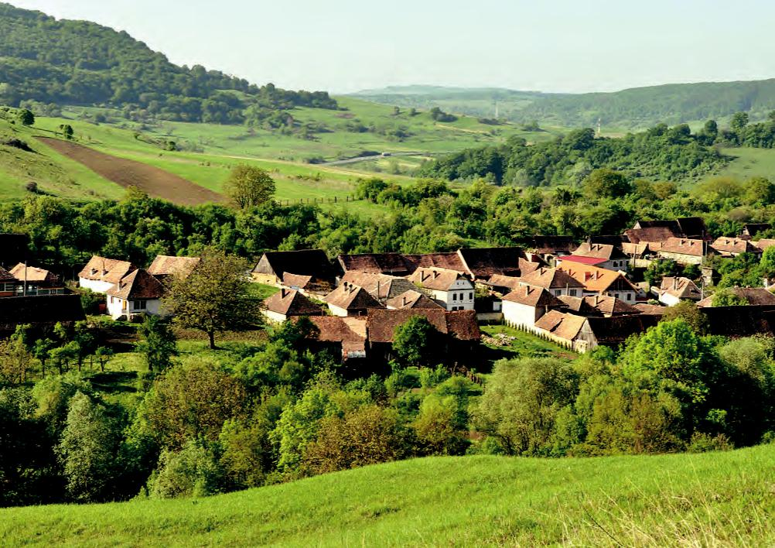

***The region of Southern Transylvania and its history***

Previous research was located in the Hârtibaciului-Târnava Mare-Olt plateau area of Southern Transylvania, spreading over 270,000 ha among the cities of Brașov, Sibiu and Sighișoara. There are several reasons why research was undertaken there.

First, Southern Transylvania abounds in cultural and ecological treasures which need to be taken care of. Its rich history of Saxons and multi-ethnic heritage makes it an exceptional and unique region. Saxons first settled in this area during the middle ages, and for several centuries were the most populous ethnic group contributing significantly to the region’s cultural and ecological heritage.

During the last century, the region underwent a series of drastic social, cultural and economic changes such as the separation from Hungary and addition to Romania as well as the rise and fall of a communistic regime. Along with these changes, the number of Saxons living in Transylvania declined progressively, as many Saxons emigrated to Germany. Nowadays, they only make up one percent of the Romanian inhabitants. The large majority of the population are Romanians, Hungarians and Roma.

Centuries of gradual cultural development went hand in hand with a vast array of traditional land use practices. These practices created one of Europe’s most notable cultural landscapes and exceptionally valuable regional “biodiversity hotspots”. With approximately one third of the landscape forested, one third covered by pastures, and the remainder covered by small agricultural fields, the region you overlook offers a rich fabric of different environments which provide habitat for many species that have become rare in other parts of Europe. Such species include the brown bear (*Ursus arctos*), wolf (*Canis lupus*) and wildcat (*Felis silvestris silvestris*), but also bird species such as the corncrake (*Crex crex*) and amphibians such as the yellow-bellied toad (*Bombina variegata*), as well as a vast range of beautiful wildflower species and butterflies associated with traditional hay meadows, such as the Danube clouded yellow *(Colias myrmidone).*

*Transylvanian Wildlife*

*From left to right and top to bottom: Wildcata, Corncrake, Danube clouded yellowb, Brown bearc*.

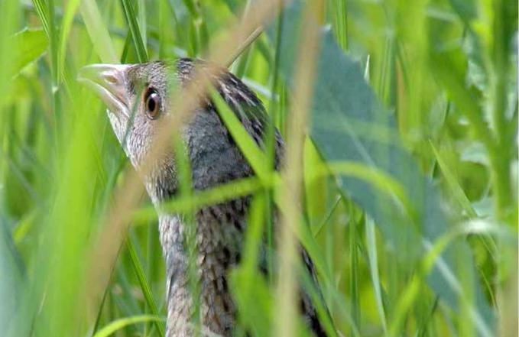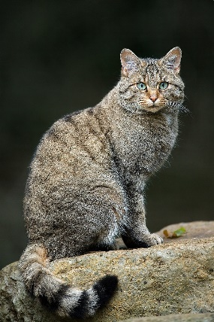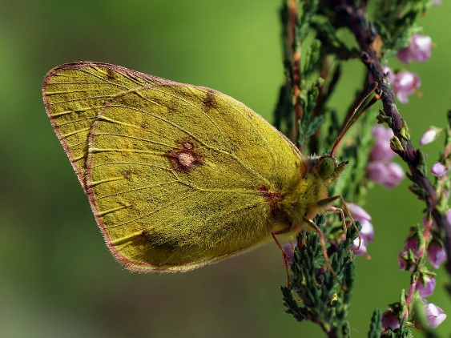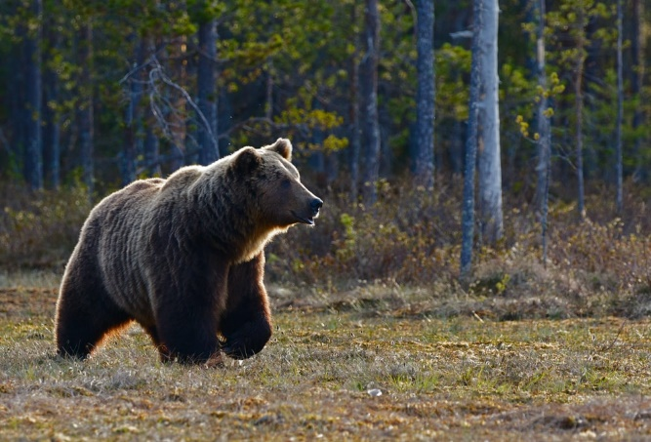

Another reason for taking a closer look at the region’s future is that these cultural and ecological treasures are increasingly threatened. Change is in the air for Southern Transylvania.

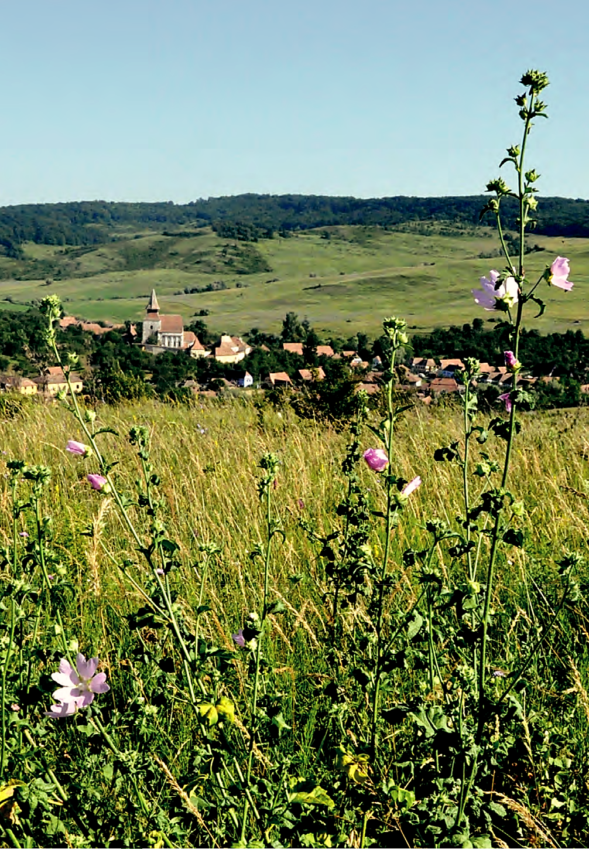

With Romania’s accession to the European Union in 2007, socio-economic conditions have begun to shift rapidly again. As a result, traditional smallholder agriculture is increasingly less viable, many young people migrate seasonally or are permanently in search of more profitable livelihoods. Many smallholder farmers still act according to the traditional community value systems they inherited from the past, even though the external world has changed. Thus, certain practices still persist, to the benefit of sustainability, but are declining and are at risk of being lost at some point. This impending loss of traditional practices and values also opens up opportunities to engage with the local people facing this rapid and massive landscape change at a time when they are still connected to nature; and at a time when the landscape interface is still strong enough to provide a foundation for a sustainable future. The point here is not that the past shall be restored: but not all has been lost thanks to the memory in the social sub-system. Certain land use practices in Transylvania appear to be partly upheld by this value debt. Thus, this is both a warning signal and an opportunity to get engaged before it is too late.

Weak governance, corruption, low social capital and low profitability of small-scale farming underlie social feedbacks, while landscape heterogeneity, cultural land ties and traditional practices heavily influence the ecological dynamics of Southern Transylvania. Supra-national policies of the European Union and the influence of global markets are some of the most important drivers of change which outline the regional challenge of conserving the unique cultural and natural heritage of Southern Transylvania. In response to these challenges and as part of the social subsystem, there are various non-governmental organizations that try to foster and act towards sustainability through numerous local initiatives.

If the future development of Southern Transylvania is managed well, these changes can be taken in stride, leading to a region that is socially, ecologically, and economically prosperous. However, managed poorly, change can also threaten to end Transylvania’s valuable cultural and ecological heritage.

***Previous socio-ecological studies and research projects in Southern Transylvania***

Social-ecological systems are complex systems that exhibit critical thresholds, multiple drivers of change and reciprocal feedback between social and ecological components. Researchers in Southern Transylvania studied components of the ecological subsystems, components of the social subsystems, inter-relations between the two and direct as well as indirect drivers of change.

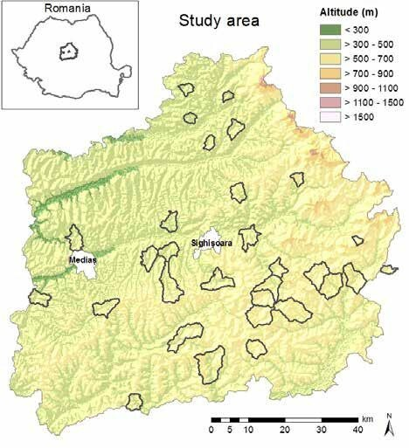

*Socio-ecological research area**Study area in Transylvania. Thirty villages and their surrounding land were targeted for in-depth investigation, outlined in black (Loos et al., 2016, p. 26).*

The research projects involved many hundreds of interviews and workshops with local people, as well as many months of detailed ecological surveys resulting in a system’s understanding of how Transylvania will develop over the next 30 years. All in all, in the span of five years of research undertaken in the region (2011-2016), a systemic understanding of Southern Transylvania was gained with an inter- and transdisciplinary, place-based social-ecological approach that addressed the challenge of sustainability in the cultural landscapes. An overview of this transdisciplinary work in Southern Transylvania can be found in the books “Sustainable Landscapes in Central Romania” and “The Future of People and Nature in Southern Transylvania” (Fischer et al., 2015; Loos et al., 2016).

Throughout the research, the exchange between sustainability initiatives and researchers became more intense, as a researcher reports:

*“During our long-term engagement with the practitioners of change in the area, we also co-generated in a scenario building exercise a shared vision called Balance Brings Beauty for the future of Southern Transylvania up to 2043. In short, this vision outlined a future that balances a good quality of life with ecological sustainability. It provided a useful object to shaping the case with NGOs”* – Horcea-Milcu, A. (2020).

***Scenario Planning***

Scenario Planning was adopted in the Transylvanian context with the aim to facilitate moving the social-ecological system towards a widely shared vision for the future of Southern Transylvania.

Scenario planning is a method that has been used in many different contexts, for example by military leaders who did scenario planning to better be prepared for unforeseen attacks by enemies. Business leaders have used it to adapt to changing conditions in markets and to navigate competition with other companies. Local people and government offices also use this method to navigate socio-economic and environmental change. In general, scenario planning is a structured way to think about and prepare for an uncertain future. While there are many variants of the method, a common one is to identify so-called “critical uncertainties” about the future. Such uncertainties can then be thought through regarding their likely impact on the system of interest.

The final target vision for Southern Transylvania was co-developed and co-validated in scenario building exercises with local actors at the end of 2012. This elaborate and participatory process took several years but finally identified plausible trajectories of future development for Southern Transylvania.

At the end of the process, two critical uncertainties were determined. The first one related to the extent to which policies by the European Union (EU) would favor economic development versus environmental sustainability. The second uncertainty regarded the extent to which local stakeholders would be able to work together towards a shared goal as well as the ability to keep up strong ties in the community. Crossing these two uncertainties resulted in four plausible scenarios for what Southern Transylvania might look like 30 years from now.

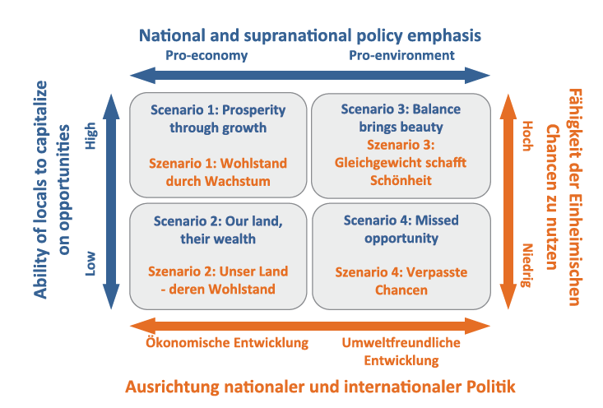

*Scenario Planning for Southern Transylvania*

*Schematic summary of four different scenarios for Southern Transylvania in 2043 (Fischer et al., 2015, p. 23).*

***The Balance Brings Beauty Scenario***

One of the four scenarios named *Balance Brings Beauty* was widely agreed to be the most preferred scenario for the region by a range of local actors.

*Balance Brings Beauty* describes a target vision for 2050 in which local people have the possibility to take advantage of opportunities through collaboration and joint initiatives. The scenario lies in a context of pro-environmental conditions through national and supra-national policy. Within the *Balance Brings Beauty* scenario, strong local communities are able to capitalize on high national and international demand for organic agricultural products. A sustainable use of resources co-exists with intensified land use via modern organic farming methods. Furthermore, vibrant cultural tourism and eco-tourism stabilize people’s incomes from the agricultural sector. Although few people are financially wealthy, economic and social inequalities are relatively low, and community spirit is high. Cultural and natural capital is valued and actively maintained.

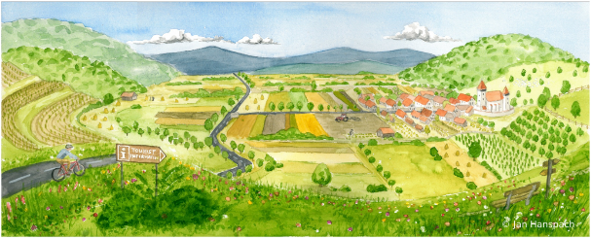

*Balance Brings Beauty Scenario  
Visual summary of the scenario for Southern Transylvania in 2043 (Fischer et al., 2015, p. 86).*

***Moving towards the shared vision for Southern Transylvania***

The preference for the *Balance Brings Beauty* scenario was validated during outreach activities with local communities in 2014. The scenario gained popularity across many different stakeholders representing a wide range of different interests and can be seen as a broadly shared vision for the future of the region. Since then, local initiatives and NGOs have also begun to use the scenario in their work to communicate with external parties. That is a very promising starting point! But how can this vision be reached and who needs to be engaged in these processes?

During the previous research, various local initiatives and NGOs were identified which already try to engage with the regional sustainability challenges in Transylvania, such as the loss of biodiversity or cultural heritage. Numerous initiatives exist which deal with nature and cultural heritage conservation, supporting small-scale farming, eco-tourism, or rural communities and several of them have also come together to create an eco-tourism board for the region (see Appendix A for descriptions of NGOs & initiatives working in the area).

For example, the Mihai Eminescu Trust is an NGO that leads different initiatives to conserve and regenerate villages and communities in Transylvania by, for instance, revitalizing traditional handicrafts, or supporting farmers to access communal pastureland for their livestock ([www.mihaieminescutrust.org](http://www.mihaieminescutrust.org)). Another example is the organization Fundatia ADEPT, which encourages the protection of landscapes and farming communities by implementing conservation measures or rural development projects (<https://fundatia-adept.org>). Another noteworthy NGO is SCHUBZ România. It is a center of education for sustainable development which aims to bring sustainability into the everyday life of children and teenagers by creating experiences which connect them to nature and their heritage (<https://schubz.ro/en/>).

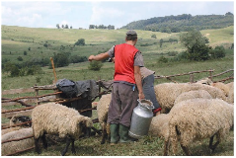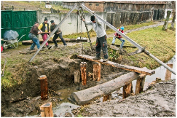

Altogether, there is a plethora of work already being done in the region: These three initiatives and many more are locally very relevant and are key to leading the local pathway towards the widely agreed upon vision of Balance Brings Beauty. Navigating the drastic changes Transylvania is facing while maintaining the objective of this vision - a balanced progress in social, economic and environmental spheres - can only be achieved through collaborative efforts with and among these initiatives and NGOs.

*Local initiatives and NGOs  
 From top to bottom:  METd, Fundatia ADEPTe, SCHUBZ Româniaf.*

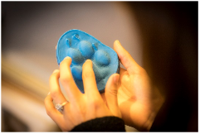

***Building up a transdisciplinary research project***

As you slowly come down from the ridge and reach the historic village in the flat valley, you deeply breathe some fresh air while you mentally prepare yourself for the arduous but exciting time ahead. You re-enter the meeting room and sit down at the table with the other members of your transdisciplinary research team. Now it is time for you to think about how the *Balance Brings Beauty* scenario can be reached by collaborating with the networks and relationships that have been built with local actors and initiatives over the last years.

Together, you are designing a transdisciplinary project based on previous research projects and efforts in Southern Transylvania.

**Main Task of the Case Study**

With your research team, develop a transdisciplinary project spanning 3 years. Its goal is to set in motion critical development for making the scenario *Balance brings Beauty* reality. For this, you will collaborate with one of the local initiatives/NGOs detailed above, that serves as your primary contact stakeholder. Within your team, two of you will take on the role of scientific experts in a certain field of your choice. Both the contact stakeholder and the experts will influence your project design.

You will have unlimited personal and financial resources. If necessary, you can make assumptions on what is happening and how these developments impact your project process.

***Image content***

With permission from Fischer et al. (2015) and Loos et al. (2016).

1. Lviatour (2013). A European Wildcat [Photograph]. Available at <https://commons.wikimedia.org/wiki/File:Felis_silvestris_silvestris_Luc_Viatour.jpg>, last accessed on 05.03.21.
2. Ustyantsev, I. (2016). Colias Myrmidone [Photograph]. Available at <https://www.flickr.com/photos/155939562@N05/39366518650>, last accessed on 05.03.21.
3. Macháček, Z. (2019). Brown Bear [Photograph]. Available at <https://unsplash.com/photos/_QG2C0q6J-s>, last accessed on 05.03.21.
4. Mihai Eminescu Trust (2021). How we work [Photograph]. Available at <https://www.mihaieminescutrust.ro/en/how-we-work/>, last accessed on 05.03.21.
5. Fundatia ADEPT (2010). High Nature Value Grasslands [Photograph]. Available at <https://fundatia-adept.org/wp-content/uploads/2018/05/HNV_conference_brochure1-min.pdf>, last accessed on 05.03.21.
6. Secarescu, D. (2019). Living with Wolf, Bear and Lynx [Photograph]. Available at <https://schubz.ro/en/wp-content/uploads/sites/2/2018/10/IMG_0954_2018-09-24_SchubzRasnov_photocDanielSecarescu_photo.jpg>, last accessed on 05.03.21.

***References***

Fischer, J., Horcea-Milcu, A. I., Hartel, T., Hanspach, J., & Mikulcak, F. (2015). The future of people and nature in Southern Transylvania: Die Zukunft von Mensch und Natur in Südsiebenbürgen. Sofia: Pensoft.

Hanspach, J., Hartel, T., Milcu, A. I., Mikulcak, F., Dorresteijn, I., Loos, J., … Fischer, J. (2014). A holistic approach to studying social-ecological systems and its application to southern Transylvania. *Ecology and Society*, *19*(4), art32. doi: 10.5751/ES-06915-190432

Horcea-Milcu, A. I., Abson, D. J., Dorresteijn, I., Loos, J., Hanspach, J., & Fischer, J. (2018). The role of co-evolutionary development and value change debt in navigating transitioning cultural landscapes: The case of Southern Transylvania. *Journal of Environmental Planning and Management*, *61*(5–6), 800–817. doi: 10.1080/09640568.2017.1332985

Loos, J., Abson, D.J., Dorrensteijn, I., Hanspach, J., ... Fischer, J. (2016). Sustainable Landscapes in Central Romania: A Social-Ecological Study on the Future of Southern Transylvania: Pensoft.

Milcu, A. I. (2014). Navigating conflicting landscape aspirations: Application of a photo-based Q-method in Transylvania (Central Romania). *Land Use Policy*, 15.

Nieto-Romero, M., Milcu, A., Leventon, J., Mikulcak, F., & Fischer, J. (2016). The role of scenarios in fostering collective action for sustainable development: Lessons from central Romania. *Land Use Policy*, *50*, 156–168. doi: 10.1016/j.landusepol.2015.09.013

***Appendix A:***

***Overview of initiatives and NGOs active in Southern Transylvania***

*Anonymized descriptions adapted from Supplementary Materials of Lam, D. P., Martín-López, B., Horcea-Milcu, A. I., & Lang, D. J. (2020). A leverage points perspective on social networks to understand sustainability transformations: evidence from Southern Transylvania. Sustainability Science.*

|  |  |
| --- | --- |
| **Name** | **Description** |
| A | County association established at the initiative of over 20 rural municipalities concerned with the sustainable development of the county. The aim is to promote the nature, traditions and the landscape in its entirety of this historical county. The specific focus of this association’s activities lies in developing intercommunity relationships and promoting local tourism. The association is seeking to attract funding in order to support the rural practices that local tourism is dependent upon. |
| B | National association with numerous projects in Transylvania. The mission of the association is to establish a connection between ecotourism and nature conservation by establishing partnerships between the private and the public sector. The association is also creating mechanisms for the certification of local ecotourism initiatives. |
| C | National association dedicated to peasant farmers’ mutual support. The association advocates for their rights and better economic conditions. It ensures their access to pasture land and local seeds for socially and ecologically sustainable land management. The association is also contributing the visibility of rural lifestyles and communities and advocates for more aware relationships between producers and consumers. |
| D | Local association involved in socio-economic and cultural activities with a view towards sustainable development. The association is on a mission to relaunch the local economy and revive the local cultural heritage. It does so by highlighting and stimulating local initiatives based on community, socio-cultural and sustainability values. |
| E | County association aiming to develop local tourism taking into account the principles of sustainable tourism. It bridges between the public and private sector in setting the strategic directions for the development of the county tourism. It encourages the engagement of communities and their sense of responsibility for the continuity of the cultural heritage. |
| F | Association active at a micro-regional level that aims to elaborate a sustainable development strategy with a special view to the particular ecological and cultural character of the micro-region. Exemplary initiatives of the association are establishing support associations for milk producers and managing the natural park milk collection points. |
| G | The association is on a mission to develop local communities by reconnecting them to their landscape, especially through education towards rediscovering the region’s foods and traditional food production. The association organises alternative tourism events and encourages local entrepreneurship. Values guiding its vision are sustainability and  creativity. |
| H | The main focus of the association are the strategic law suits on environment protection issues, heritage protection, and academic integrity (e.g. anti-plagiarism). For example, they organize court campaigns against companies that cut wood to set up power plants, as well as lawsuits against abusive wood harvesting processes. Their profile also includes support for ethnic minorities’ rights in Romania. |
| I | The vision, mission and values of this environmental NGO centre around raising the awareness of people regarding nature’s values. Their practice of nature conservation includes protecting endangered species, enforcing laws while influencing policies regarding nature. They are also actively trying to popularise the notion of ecosystem services and to map regional ecosystem services in order to influence local to national decision-making mechanisms. |
| J | Local association dedicated to conserving the cultural identity of rural life in Transylvania. It engages in building local information points about the history and traditions of Transylvanian villages for those interested in cultural and rural tourism and for supporting the local communities to better express their identity. |
| K | National foundation that advocates for the preservation and restoration of the architectural heritage of Romania. It is engaged in networks that respect traditional craftsmanship and appropriate construction techniques. It provides support for the re-use of historic buildings, teaching people to appreciate their value. |
| L | Association active at county level towards the sustainable development of communities living in one of Transylvania’s counties. In elaborating the local development strategy it tried to bring together local actors from all these communities. In order to inform, advice  and offer funding to local stakeholders the association is carrying out regular fieldwork. |
| M | Institution that deals with the preservation and practice of one of the religions in Transylvania. To do so, it also invests in the maintenance of its built heritage and in educational activities for local communities. It has numerous international partnerships with numerous organisations that share similar orientations. |
| N | Initiative for the development of ecotourism infrastructure and facilities through local networking and relying entirely on the cooperation among local actors. It emerged during consultations with local actors regarding the development of a tourism strategy for a protected area in Southern Transylvania. It promotes Southern Transylvania as a region that shares a common cultural, aesthetic and economic background. |
| O | Association of organisations active in the field of heritage conservation and community development. It provides resources and expertise for its members, while carrying out common projects and sharing best practices. It aims to facilitate interventions at legislative level concerning culture and environment. |
| P | Foundation dedicated to the rural development and capacity-building of the farming landscapes of Transylvania. In its practice of conservation of biodiversity, the foundation tries to integrate social and economic benefits for the traditional farming communities. For example, it encourages the acquisition of small units for processing community grown fruits and vegetables. |
| Q | Foundation with the goal of maintaining the cultural and religious heritage of Transylvania. To do so, it performs a large number of activities that go beyond the fields of construction and preservation of the religious landmarks, particularly regarding local communities. |
| R | National foundation providing capacity building for the conservation of protected areas through integrated methods and tools. It trains and offers comprehensive mentorship to local, national and international actors in order to improve the performance of critical natural resources management. |
| S | Regional foundation for the integrated development of cultural heritage in the rural and urban environment. Among its activities there are the rehabilitation of historical buildings in the context of urban and rural development with a focus on tourism and sustainable development. |
| T | Local association delivering the local development strategy with foci on agriculture, forestry, environment and folklore. It also supports women living in the villages to produce and sell added-value products and fosters the ethnical diversity. |
| U | Local association that distributes funding and other supporting materials to assist the development of local farming and entrepreneurship. It promotes the material, immaterial and natural heritage of the micro-region by organising community and town events. |
| V | Association at micro-regional level fighting rural depopulation, aiming at rural ethnical integration and supporting local farming. It also deals with managing Natura 2000 sites protecting natural resources that are found on its territory. |
| W | Local association established as a public-private partnership aiming at rural development. It holds informative sessions for potential local entrepreneurs, organizes events for their promotion and advises them in applying for funding. |
| X | Local association that aims to develop a development strategy capitalising on the social and natural resources and relying on public consultations. It organizes local cultural events to promote traditions, small producers and community entrepreneurship. It partners with similar associations from Europe. |
| Y | Foundation dedicated to the conservation of cultural and built heritage. It is involved in revitalizing traditional handicrafts and developing local communities through entrepreneurship. It encourages the creation of farming association at village level in order to secure communal pasture land for small scale farmers and therefore improve the rural quality of life holistically. |
| Z | National forestry NGO with regional offices. It aims to support the development of forestry in Romania paying attention to the economy and the environment. It is open to the integration of experts from disciplines outside forestry. It is interested in adjusting current policies to the challenges of climate change. |
| AA | Educational centre for sustainable development for school children and their families using experimental and explorative learning. It mainly addresses the urban and rural communities from the neighbouring counties. It also aims to capitalize on the local heritage and traditions related to a life in harmony with nature. |
| AB | Regional programme of an international environmental NGO. Its regional office deals with protecting the wildlife of Transylvania by engaging in protected areas and biodiversity management. It develops programmes dedicated to sustainability transitions or to education especially targeting young people. |
| AC | Project initiative to conduct an inventory of ancient trees of Romania in order to recognise their multiple social-ecological and cultural values. The mapping, registering and conserving of old trees is done with the help of citizens. The data is collected and made available on an online platform with the aim to reconnect people to ancient trees and influence the legislation on protecting ancient trees. A transdisciplinary international steering committee takes strategic decisions. To date, more than 5000 trees have been registered. |