*Transdisciplinary Case Study of Southern Transylvania*

**FROM VISIONS TO REALIZATIONS –**

**Keeping the past alive while enabling the future**

**Manual for Instructors**

This Case Study was constructed within the tdAcademy project, which aims to build a transdisciplinary knowledge platform. Founding partners are the Frankfurt Institute for Social-Ecological Research, the Center for Technology and Society at Technische Universität Berlin, the Öko-Institut in Freiburg and the Leuphana University Lüneburg.  
In this Case Study, participants will be encouraged to learn from sustainability issues and real-world transdisciplinary research in Southern Transylvania.

**Educational Objectives**

Throughout this Case Study, participants should...

* Learn some **basics of transdisciplinary research** **and related methods** by applying it to a real-world context
* Gain first insights on **how to design transdisciplinary research projects**
* **Work collaboratively** in teams and find out about **new tools and methods** for effective team-work
* Get to know your **competencies as a transdisciplinary researcher**
* Adopt a role as a **leading position in a transdisciplinary research project**

Their learnings will relate to topic lines of tdAcademy, which investigate core questions of transdisciplinary research, such as:

1. The **societal effects** of transdisciplinary research,
2. The **scientific effects**of transdisciplinary research,
3. Dealing with **contextual dependencies**.

**About the Case Study**

The Case Study’s structure was adapted from the Harvard Business Case Studies, which have established themselves as valuable educational practice in the business context.

The participants’ main task will be to construct a fictitious transdisciplinary research project. The Case Study consists of three parts and will be worked on in groups. Before the participant’s start with the construction of their research projects, they will have time to getting to know each other and for general group organization. In order to simulate contextual dependencies, each group will be allocated a different primary contact stakeholder, whom they will be constructing their project with. The groups will also select two of their members to be ‘scientific experts’ in a chosen field which shows the diversity in research projects and potential scientific impacts.

Then, the participants will start working together on their main task. For constructing the fictitious research projects, the Case Study Description and additional materials contain necessary information about Southern Transylvania.

As the third part, the groups will present their results to each other and reflect on their processes and learnings.

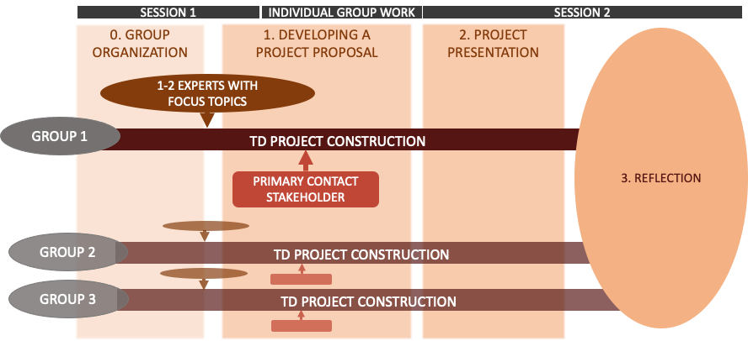**Course Structure and Schedule**

**Before** the course starts...

Please send a **mail** out to all participants. A suggestion for such a mail is provided in the Case Study package. It should contain...

* Mandatory Readings: Case description & key transdisciplinary literature (to be read by the participants before the first session)
* Reflection task for participants: What are skills they have or topics they are interested in which could impact their own transdisciplinary research?

**During** the Course...

In the Case Study package, you are provided with two power point presentations containing all additional requirements - one for each session of the Case Study. **The outlined times for tasks and breaks below are suggestions.**

***Session 1***

* **Introduction [30 mins]**
  + Please *give an overview*of the Case Study (learning objectives, impressions of Southern Transylvania, structure) and the tasks ahead (Slide 1-6).
    - Note to Slide 4: Video serves to gain first impressions of the region rather than demonstrating challenges.
    - Note to Slide 6: Encourage to be creative and brave within this task, there are no right or wrong decisions to be made. When setting up a transdisciplinary project, use the high degree of freedom and flexibility as a researcher. Setting a clear focus in their projects helps to meet expectations within the given time frame.
  + Let the participants know where the PowerPoint slides are uploaded. All material can be found in the slides and will be necessary for working on the tasks.
  + *Sort**all participants into groups of 4-5.*
* **Group Organization - Task 0** (Slide 7-10)
  + The different groups now have time to get to know each (refer to reflection task prior course start) other and to organize themselves as a group. Exemplary pointers for orientation and structuring the organization phase are given on Slide 9-10. As an instructor, you are free to *provide participants with further ideas and tools* for improved group organization, such as data sharing and communication tools **[35 mins]**.
* **Short Break [ca. 5 mins].**
* *Get back into the plenary, resolve questions or difficulties and present the next two tasks, that will be worked on in break out rooms.* 
  + **Select Experts - Task 1A** (Slide 11-13): Although every group member is expert in a certain field, for the sake of simplicity two ‘scientific experts’ will be chosen by each group and take on a suggested or individual focus topic. It can be advised to collect individual focus topics from the reflection task first. Please also note: These experts will have to do individual research for their roles.
  + **Primary contact stakeholders - Task 1B** (Slide 14): *Allocate* one of the three different *primary contact stakeholders to each group*. They will find information on their stakeholders in the material slides and on the linked websites, for now they should try to get an overview and a feeling for their stakeholder. The provided questions on the slides can also be worked on later and are important for the later project construction. The groups can decide individually how deeply they want to involve other stakeholders too (see table on p.11-14 in case description).
  + Groups should work on Task 1A and 1B separately, starting with A. Suggested time for tasks in breakout sessions: **[15 + 15 mins or longer]**.
* *Get back into the plenary, discuss questions, present the next task.*
  + **Develop a project proposal - Task 1C** (Slide 21): Participants will have **the remaining time** in the session to start developing their project proposals. *Please help your participants with this task and provide them with feedback. Introduce the participants to the td-net Toolbox* and, if found necessary, the method of Design Thinking or other methods you prefer (Slides 23-25). There is a variety of further materials on TD project construction in the material slides for this task (Slides 18-25).
  + **During break out session: Give participants the option to take a longer break [ca. 20 mins]**
* **Presentation of the transdisciplinary project - Task 2** (Slides 26-27): *Get back in the plenary* **15 mins before the end of the Session** *and present the requirements for the project presentations which will be held in Session 2*. Additional requirements for the participants’ project presentations, e.g., format, can be added by you. Under the conditions that the task is given in, it is not expected to present a completed project proposal.

***Session 2***

* *Present agenda and start an introduction round (e.g. ask how they are feeling about their projects). Collect impressions orally and lead over to the project presentations* (Slide 3).
* **Project Presentations** (Slide 3): presentations à 10-15 mins plus 5 mins room for questions & discussion each.Optional short break after second presentation ca. 5 mins**. [50-70 mins].**
* **Case Study Reflection** (Slide 4, optional collection of impressions on a sharing platform e.g. Miro Board):
  + Individual reflection, suggested *in plenary* **[15 mins]**
  + Group reflection, suggested *in break out rooms* within the working groups **[25 mins]**
  + **Long Break [ca. 20 mins]**
  + *Get back into the plenary.* Hold *plenary discussion* **[20 mins]**
* **What really happened…** (Slide 5-6)**:** Presentation of the Leverage Points Project in Southern Transylvania (optional, refer to video presentation by Daniel J. Lang 37 mins.) and further readings. **[15 mins]**
* **Feedback [10-15 mins prior session ends]:** *Please inform the participants to fill in the feedback form and potentially ask for further criticism and comments in the plenary.*

**Contact of Case Study developers**

**Farina Tolksdorf:** farina.l.tolksdorf@stud.leuphana.de

**Annette Räther**: [annette.raether@stud.leuphana.de](mailto:annette.raether@stud.leuphana.de)

**Dr. David P. M. Lam:** lam@leuphana.de

